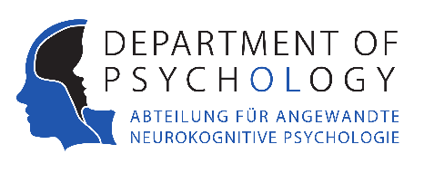

Master Project in the Applied Neurocognitive Psychology Lab
Topic: Characterization of neural responses to speech in subcortical structures
This is a collaborative project between the Applied Neurocognitive Psychology Lab (Prof. Rieger) at the University of Oldenburg and the Institute of Neurophysiology at the Medical Center Hamburg-Eppendorf (UKE, Dr. Moll). The aim of the project is to characterize neural responses (single-unit responses, local field potentials, and electroencephalography) to speech in subcortical structures. Recordings were obtained from patients with local anesthesia or general anesthesia suffering from diseases such as Parkinson’s disease and implanted with subcortical electrodes at UKE. These data will be analyzed by the Master student in the lab in Oldenburg with an opportunity to visit the lab at UKE to learn data analysis methods and attend intracranial patient recordings.

We are looking for a student with a background in psychology, neuroscience, medical physics, bioengineering or computer science. The ideal candidate has some experience in one or more of the following fields: programming (e.g. Matlab), electrophysiological data analysis, neuroscience and auditory/speech research.

If you are interested in this project, please contact Prof. Jochem Rieger (jochem.rieger@uni-oldenburg.de) or Dr. Inga Schepers (inga.maren.schepers@uni-oldenburg.de).

Date of announcement: 11.04.2016

